实验二 实验报告

一.信号类型

1.连续时间信号

t=0:0.01:10

y=cos(t);

plot(t,y,'LineWidth',2)

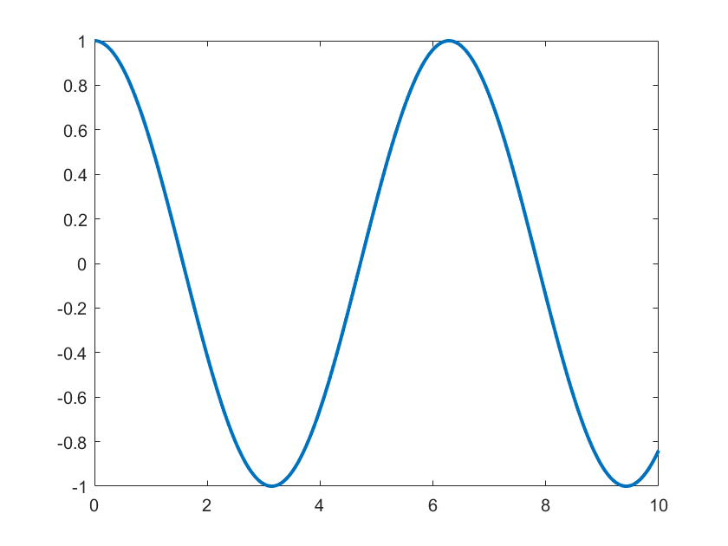

2.离散时间信号

n=0:10

y=cos(n);

figure

plot(n,y,':o')

figure

stem(n,y)

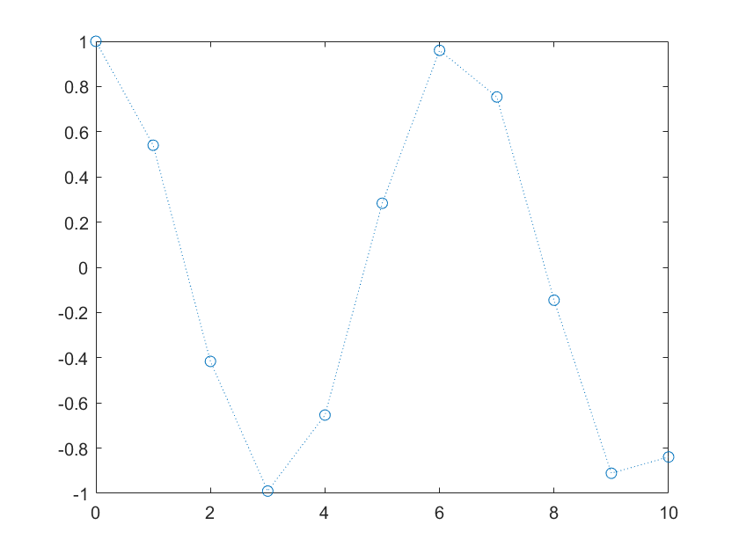

3.数字信号

n=0:10

y=cos(n);

y=round(y);

figure

plot(n,y,':o','LineWidth',2)

figure

stem(n,y,LineWidth=2)

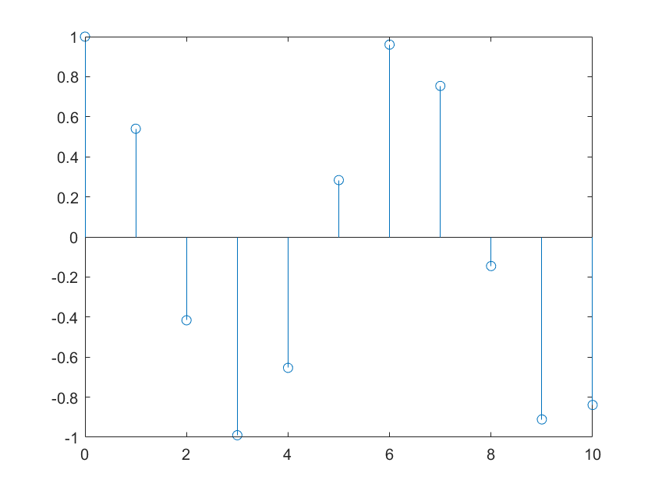

二.基本连续时间信号

1.正弦信号

A=3;

omega=3*pi;

thita=pi/3;

T= 2*pi/omega;

t=0:0.01:4*T;

x=A*cos(omega*t+thita);

plot(t,x)

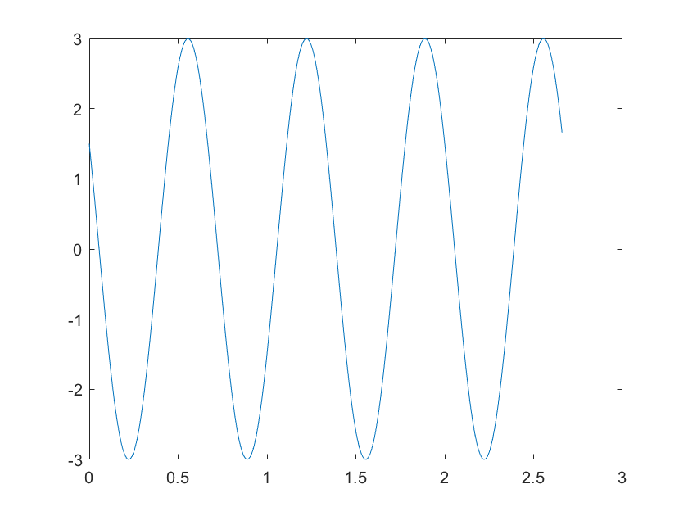

% 正余弦信号：cos(t)=sin(t+0.5*pi)

figure

t=0:0.1:2*pi;

x1=cos(t);

x2=sin(t+pi/2);

plot(t,x1,t,x2,'o')

xlim([0 2*pi])

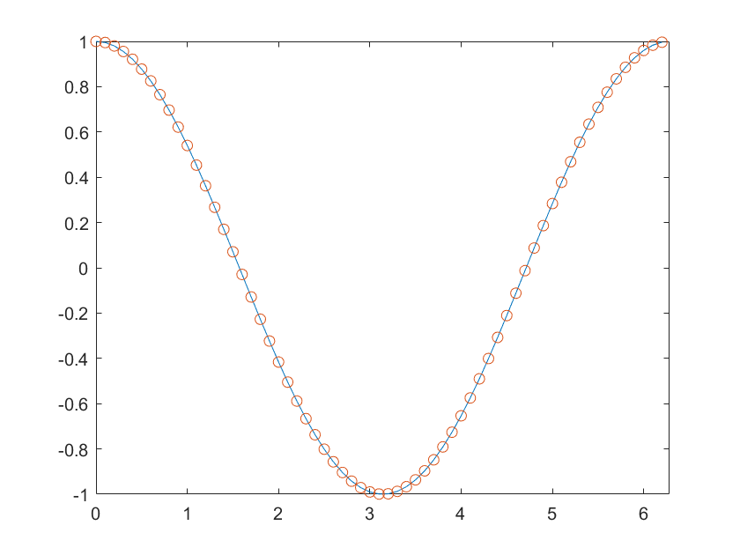

2.指数信号

figure

t=-2:.1:5;

x=3*exp(0.4*t);

y=2*exp(-0.9*t);

plot(t,x,t,y,':',LineWidth=2);

legend('x(t)','y(t)')

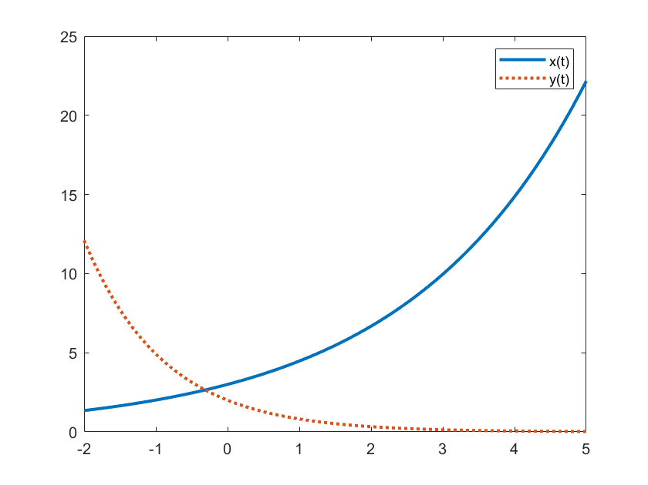

3.负指数信号

figure

t=0:.1:2;

y_re=real(2*exp(j*pi*t+pi/3));

y_im=imag(2*exp(j*pi*t+pi/3));

plot(t,y_re,t,y_im,'-.',LineWidth=2);

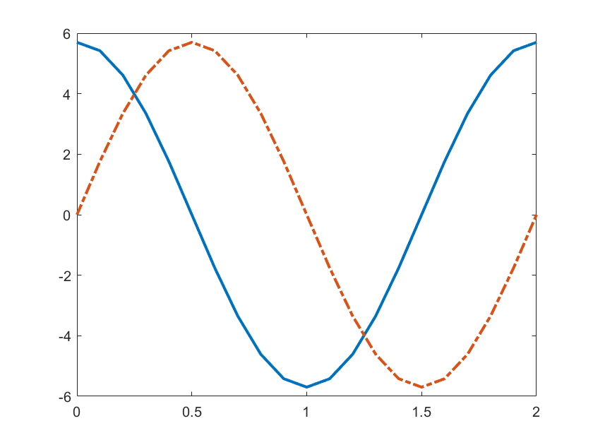

figure

t=0:0.1:5;

x=(2*exp(j*pi*t)).*(3*exp(j*2*pi*t));

y=6*exp(j*3*pi*t);

plot(t,real(x),t,real(y),'ko')

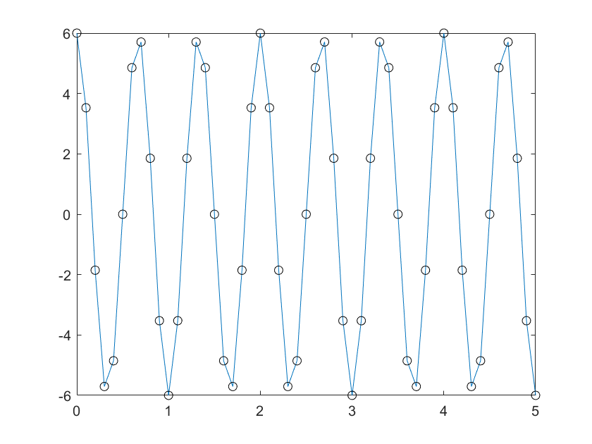

4.单位阶跃函数

t=-5:0.1:10;

u=heaviside(t)

plot(t,u)

ylim([-0.3 1.3])

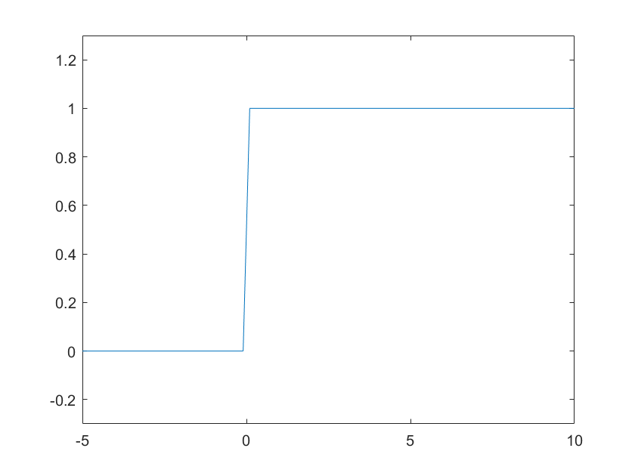

figure

t1=-5:.1:0

t2=0:.1:10

u1=zeros(size(t1))

u2=ones(size(t2));

t=[t1 t2];

u=[u1 u2];

plot(t,u);

ylim([-0.3 1.3])

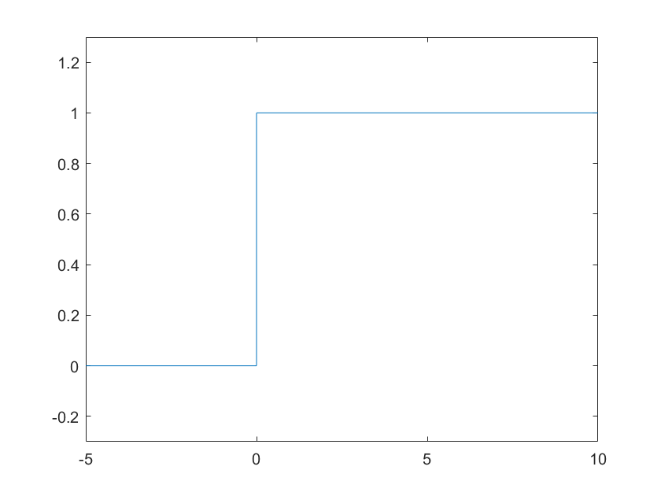

figure

t=-5:.1:10;

u=[zeros(1,50) ones(1,101)];

plot(t,u);

ylim([-0.3 1.3])

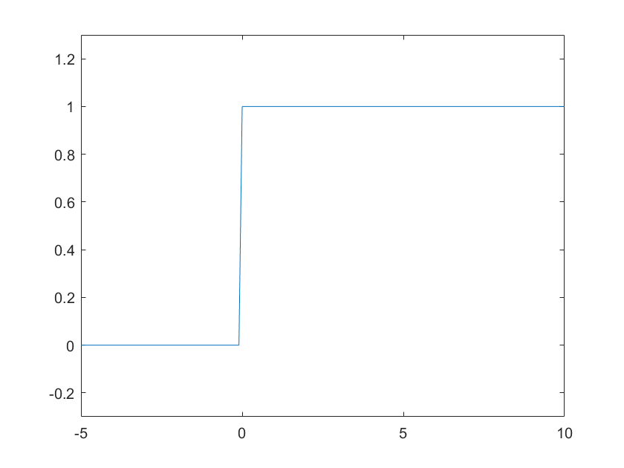

%u(t-t0)

figure

t=-5:0.1:10;

u=heaviside(t-2)

plot(t,u)

ylim([-0.3 1.3])

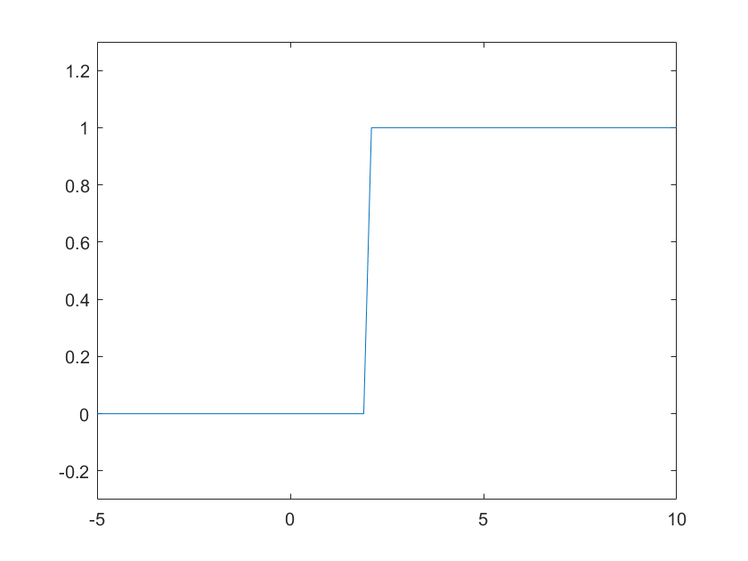

figure

t1=-5:.1:2

t2=2:.1:10

u1=zeros(size(t1));

u2=ones(size(t2));

t=[t1 t2];

u=[u1 u2];

plot(t,u)

ylim([-0.3 1.3])

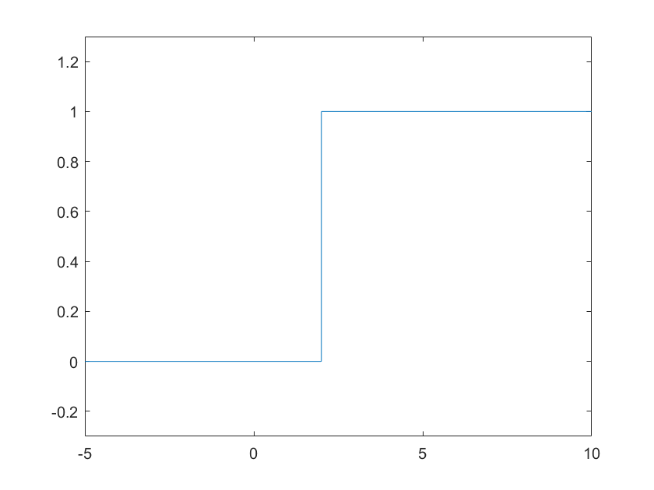

5.单位脉冲函数/狄拉克函数

t1=-5:.1:-0.1;

t2=0;

t3=0.1:.1:10;

d1=zeros(size(t1));

d2=1;

d3=zeros(size(t3));

t=[t1 t2 t3];

d=[d1 d2 d3];

plot(t,d)

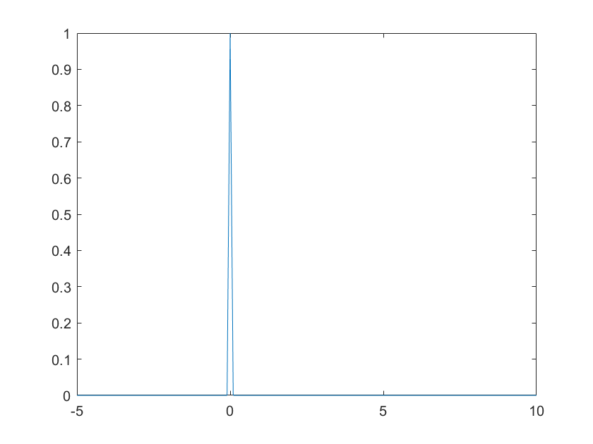

figure

t=-5:.1:10;

s=gauspuls(t)

plot(t,s)

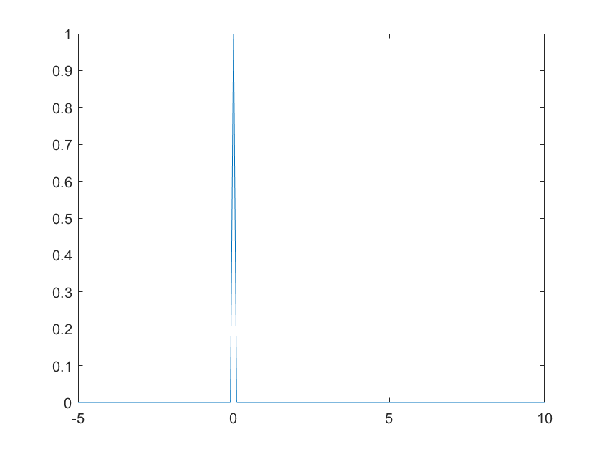

figure

t=-5:.1:10

d=[zeros(1,50) inf zeros(1,100) ];

plot(t,d)

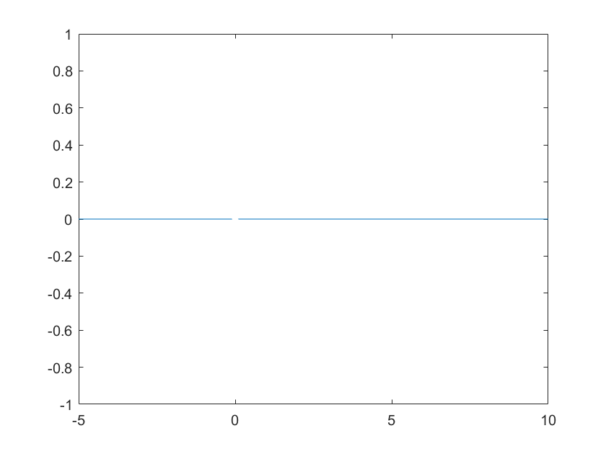

figure

t=-5:.1:10

d=dirac(t);

plot(t,d)

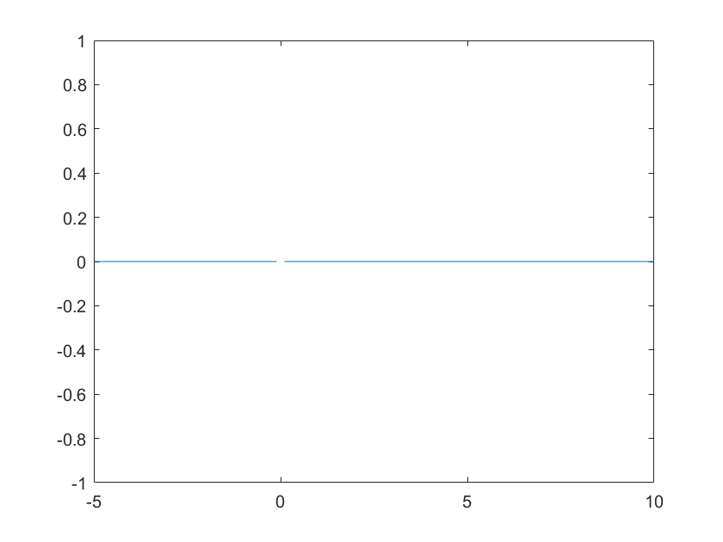

%dirac(t-t0)

t=-5:0.1:10;

d=dirac(t+2)

plot(t,d)

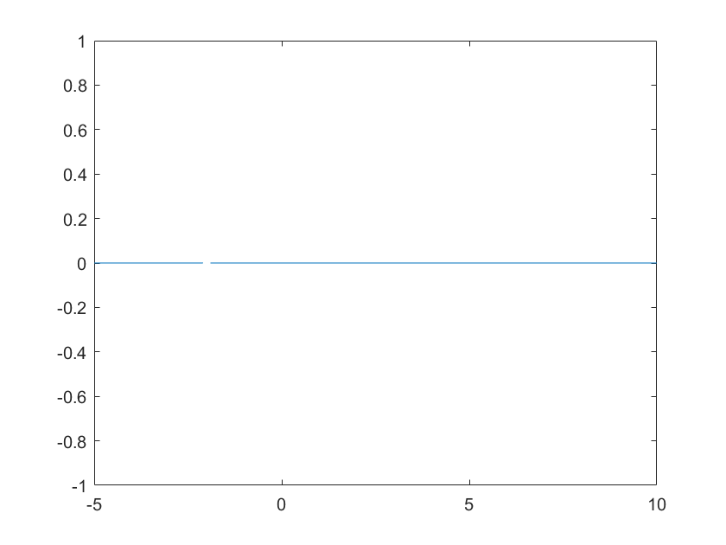

6.斜坡函数

t=-5:0.1:10;

r=t.*heaviside(t);

plot(t,r)

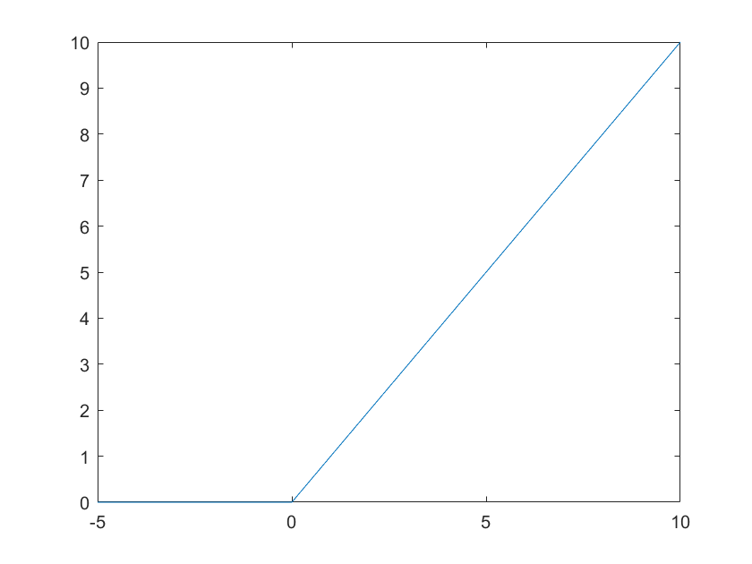

figure

t1=-5:.1:-0.1;

t2=0:.1:10;

r1=zeros(size(t1));

r2 = t2;

t=[t1 t2];

r=[r1 r2];

plot(t,r)

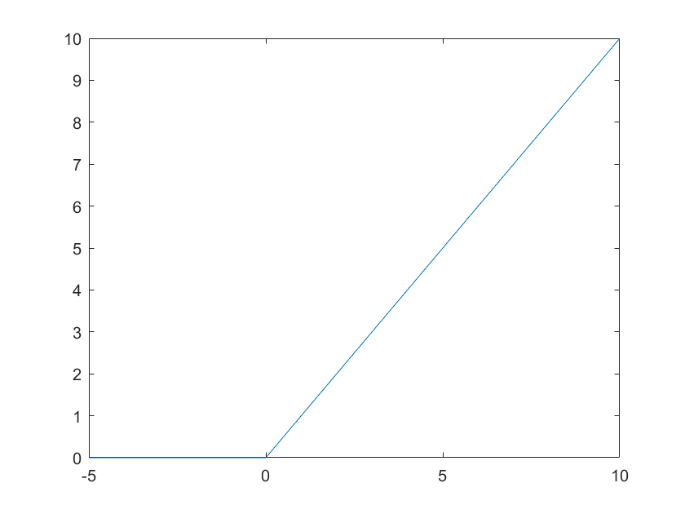

%r(t-t0)

figure

t=-5:.1:10;

r=(t-1).*heaviside(t-1)

plot(t,r)

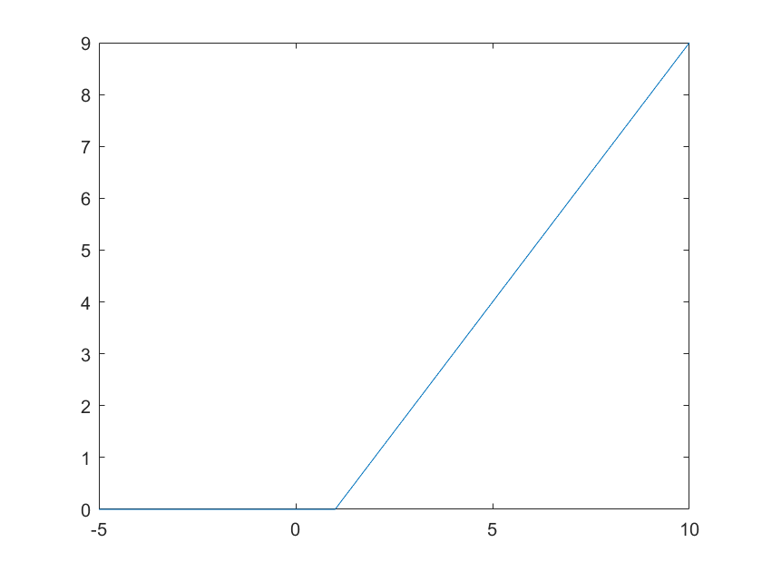

7.矩形脉冲函数

t=-5:.1:10;

u1=heaviside(t+2);

u2=heaviside(t-2);

p=u1-u2;

plot(t,p)

ylim([-0.3 1.3])

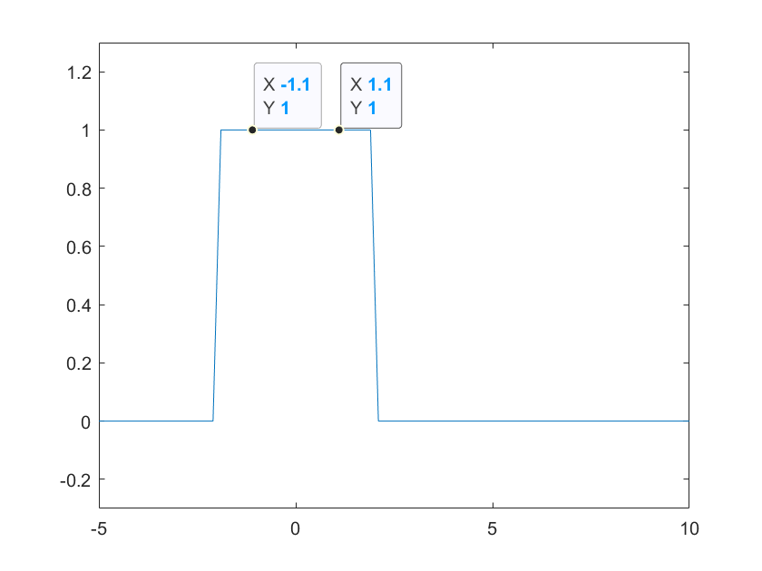

figure

t1=-5:.1:-2;

t2=-2:.1:2;

t3=2:.1:10;

p1=zeros(size(t1));

p2=ones(size(t2));

p3=zeros(size(t3));

t=[t1 t2 t3];

p=[p1 p2 p3];

plot(t,p);

ylim([-0.3 1.3]);

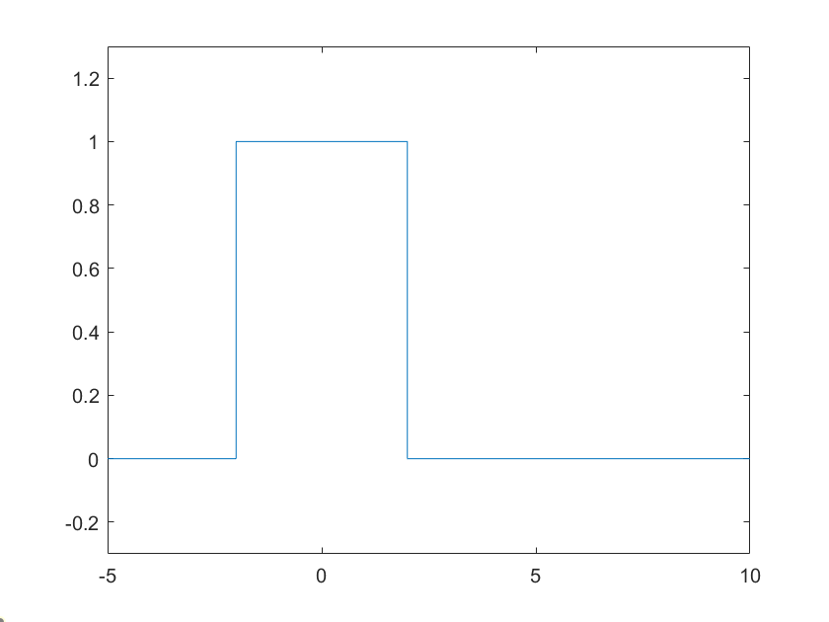

figure

t=-5:.1:10;

s=rectpuls(t,4);

plot(t,s)

ylim([-.3 1.3])

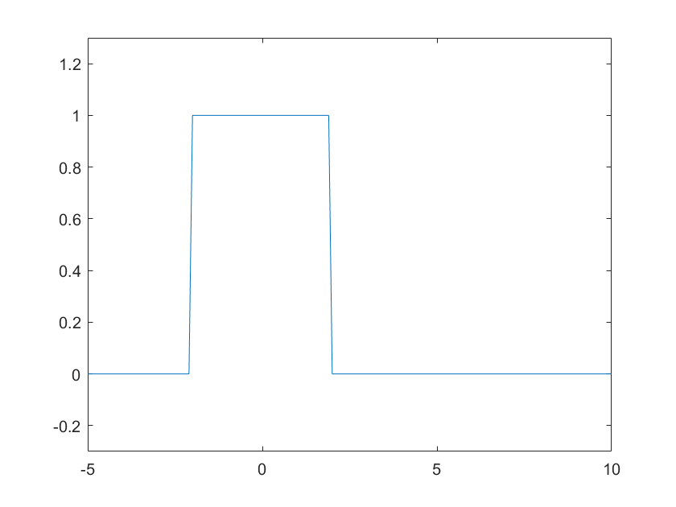

% pT(t-t0)

figure

t=-5:.1:10

u1=heaviside(t)

u2=heaviside(t-4)

p=u1-u2

plot(t,p)

ylim([-0.3 1.3])

